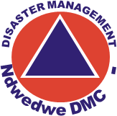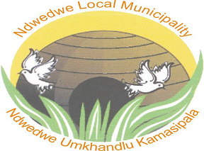

ndwedwe local municipality

disaster management
sector plan financial year 2023/2024
Table of Contents

1. INTRODUCTION AND BACKGROUND 5
2. SECTOR PLAN REQUIREMENTS. 6
3. PURPOSE 7
4. MUNICIPAL LEGISLATIVE MANDATE (DM & FIRE SERVICES) 8
4.1. Constitution of the Republic of South Africa Act no 108 of 1996 8
4.2. The National Disaster Management Framework (Notice 57 of 2005) 9
4.3. Disaster Management Act (Act No. 57 of 2002) 9
4.4. Amended Disaster Management Amendment Act 16 of 2016 10
4.5. Fire Brigade Services Act 99 of 1987 10
4.6. National Veld and Forest Act 101 of 1998 10
5. KEY PERFOMANCE AREA 1. INTERGRATED INSTITUTIONAL CAPACITY 11
5.1. Status of municipal institutional capacity 11
5.2. Status of Municipal Disaster Management Centre (DMC) 11
5.3. Status of Fire & Rescue Services 12
5.4. Status of Municipal Disaster Management Policy Framework 12
5.5. Status of Municipal Disaster Management Plan 12
5.6. Municipal Disaster Management Inter-Departmental Committee 12
5.7. Community and Social Services Portfolio Committee. 13
5.8. Municipal Disaster Management Advisory Forum (DMAF) 13
5.9. Disaster and Emergency Services SWOT Analysis 14
5.10. Challenges for Disaster Management, Fire and Rescue Services as per SWOT Analysis 15
6. KEY PERFOMANCE AREA 2: DISASTER RISK ASSESSMENT 17
6.1. List of Priority Risks in Ndwedwe Local Municipality are as follows; 17
6.2. The risk severity rating. 17
6.3. Hazard Maps 18
19
6.5. Overall Risk Map. 22
6.6. Analysis of Climate Change Risks 22
7. KEY PERFOMANCE AREA 3: DISASTER RISK REDUCTION 24
7.1. Plans for Disaster and Emergency Service Centre 24
7.2. Programs with stakeholders 24
7.3. Disaster and Fire services projects/programs with proposed budget 2023/2024. 25
8. KEY PERFORMANCE AREA 4: DISASTER RESPONSE AND RECOVERY 27
8.1. Damage assessment. 27
8.2. Rehabilitation 27
8.3. Municipal Capacity in terms of Response and Recovery. 27
8.4. Funding allocated for post-disaster recovery. 28
9. ENABLER 1. INFORMATION MANAGEMENT AND COMMUNICATION 29
9.1. Information management 29
9.2. Disaster Management Committees 30
9.3. Communication system 30
9.4. Early Warning Strategy 30
9.5. Plans for Information management & communication system in next financial year 31
10. ENABLER 2. EDUCATION, TRAINING, PUBLIC AWARENESS AND RESEARCH. 31
10.1. Planned Capacity Building Programs 31
10.2. Planned Public Disaster Awareness Campaigns 32
10.3. Planned fire safety awareness 32
10.4. Research 32
10.5. Education and training programs 32
11. ENABLER 3. FUNDING ARRANGEMENTS FOR DISASTER RISK MANAGEMENT. 33
11.1. Breakdown of available budget for disaster management and fire services. 33
11.2. Funding Mobilization Strategy 34
11.3. Private Partnerships 34

INTRODUCTION AND BACKGROUND
Disaster management has become the major challenge the entire world is faced with currently owing to the ever-growing population, climate change, and the ever-changing environment in general. Natural and man-made disasters result in economic as well as environmental losses which places a need for systematic approach to management of risks. Sector plan familiarize key role-players with legislative mandates that’s work within Disaster Management and the priority hazards within Ndwedwe jurisdiction breakdown of budget and also the planned activities in the mainstream concepts of disaster risk reduction. It provides a brief background study of the Municipality in line with its current Integrated Development Plan (IDP).

Section 53 of Disaster Management Act No. 57 of 2002 requires each municipality to prepare a Disaster Management Plan according to the circumstances prevailing in its area. Besides requirements of the DM Act, Section 26 (g) of the Municipal System Act No. 32 of 2000 also requires Municipal Disaster Management Plans to form an integral part of the municipality Integrated Development Plan (IDP). The Disaster Management Act No. 57 of 2002 requires Ndwedwe Local Municipality Disaster Risk Management to take the following actions:

  - To prepare a Municipal Disaster Risk Management Plan for its area according to the circumstances prevailing in the area and incorporating all municipal entities as well as external role-players;
  - To co-ordinate and align the implementation of its Municipal Disaster Risk Management Plan with those of other organs of state, institutional and any other relevant role-players; and
  - To regularly review and update its Municipal Disaster Risk Management Plan (refer to Disaster Management Act No. 57 of 2002 - Section 48).

SECTOR PLAN REQUIREMENTS.
The Municipal Disaster Risk Management Sector Plan should:

- Form an integral part of the Municipal’s Integrated Development Plan so that disaster risk reduction activities can be incorporated into its developmental initiatives,
- Anticipate the likely types of disaster that might occur in the Municipal’s area and their possible effects,
- Identify the communities at risk,
- Provide for appropriate prevention, risk reduction and mitigation strategies,
- Identify and address weaknesses in capacity to deal with possible disasters,
- Facilitate maximum emergency preparedness,
- Establish the operational concepts and procedures associated with day-to-day operational response to emergencies by municipal Departments and other entities. These Standard Operation Procedures (SOPs) will also form the basis for a more comprehensive disaster response.
- Incorporate all special Hazard / Risk-specific and Departmental Disaster Risk Management Plans and any related emergency procedures that are to be used in the event of a disaster.

These will provide for:
- Allocate responsibilities to the various role players and co-ordinate the carrying out of those responsibilities;
- Prompt disaster response and relief;
- Disaster recovery and rehabilitation focused on risk elimination or mitigation;
- The procurement of essential goods and services;
- Establish the strategic communication links;
- Disseminate information.

PURPOSE
The Municipal Disaster Risk Management Sector Plan is designed to establish the framework for implementation of the provisions of the Disaster Management Act No. 57 of 2002 and Disaster Risk Management Policy Framework of 2005, as well as the related provisions of the Municipal Systems Act No. 32 of 2000.
Fundamentally, the identified disaster risk reduction activities must be integrated and aligned with the main activities contained in the municipal Integrated Development Plan. Hence the purpose of this Disaster Risk Management Sector Plan is to outline approach and procedures for an integrated and coordinated disaster risk management in the municipality that focuses on:

- Preventing or reducing the risk of disasters;
- Mitigating the severity of disasters;
- Emergency preparedness;
- Rapid and effective response to disasters; and
- Post-disaster recovery.

This Disaster Risk Management Sector Plan is intended to facilitate multi-departmental, multi-agency and multi-jurisdictional co-ordination in both disaster and disaster risk management interventions.

MUNICIPAL LEGISLATIVE MANDATE (DM & FIRE SERVICES)

Constitution of the Republic of South Africa Act no 108 of 1996
The Constitution of the Republic of South Africa, places legal obligation on the government to ensure health and safety of its citizens. Section 41 of the Constitution clearly stipulates the principle of co-operative government and inter-governmental relations and specifically requires the three spheres of government to co-operate with one another in mutual trust and good faith by among others, fostering friendly relations; assisting and supporting one another; informing one another of, and consulting one another on, matters of common interest.

Furthermore, Section 41(1) (b) of the Constitution provides that all spheres of government are required to secure the wellbeing of its citizens. Firefighting services is a local municipality function with concurrent provincial and national legislative competence in terms of Schedule 4 Part B, of the South African Constitution. Notwithstanding the fact that firefighting services are rendered by the local sphere of government, both provincial and national government also have specific roles and responsibilities in terms of the Constitution, 1996.

The National Disaster Management Framework (Notice 57 of 2005)
The National Disaster Management Framework provides guidelines for the development of the provincial and municipal disaster management frameworks. The framework classifies disaster management into four Key Performance Areas (KPAs) and three Enablers. According to KPA 3- Disaster risk reduction efforts must be included into strategic integrated structures and processes. The disaster risk related information must also be incorporated into Spatial Development Frameworks (SDFs). Projects and initiatives that focus on disaster risk reduction must be included in IDPs to ensure adequate budget allocation.

Disaster Management Act (Act No. 57 of 2002)
Section 53 (2) (a) of the Disaster Management Act No. 57 of 2002 specifies that a disaster management plan for a municipal area must form an integral part of the municipality’s Integrated Development Plan (IDP). The plan must anticipate the types of disaster that are likely to occur in the municipal area and the possible effects; place emphasis on measures that reduce the vulnerability of disaster–prone areas, communities and households; take into account indigenous knowledge relating to disaster management; promote disaster management research; identify and address weaknesses in capacity to deal with possible disasters; provide for appropriate prevention and mitigation measures; establish strategic communication links; and facilitate maximum emergency preparedness and response.

Amended Disaster Management Amendment Act 16 of 2016
Section 43 of the principal act is hereby amended by the addition of the following subsection (3) A local municipality must establish capacity for the development and coordinate of a disaster management plan and implementation of a disaster management function for the municipality disaster management center. (4) A local municipality may establish a disaster management center in consultation with the relevant district municipality in accordance with the terms set out in a service level agreement between the two parties, in alignment with the national norms and standards.

Fire Brigade Services Act 99 of 1987
The Fire Brigade Services Act, Act 99 of 1987 is the primary piece of legislation regulating fire services and seeks to provide for the establishment, maintenance, employment, co-ordination and standardization of fire brigade services. In terms of this Act, local municipalities must establish and maintain a fire brigade service in order to prevent the outbreak or spread of a fire; fighting or extinguishing a fire and protection of life or property against a fire or other threatening danger.

National Veld and Forest Act 101 of 1998
The National Veld and Forest Fires Act, 1998 confers on land owners a responsibility to prevent veld fires through the provision of fire breaks and other means as well as the responsibility to fight fires. To achieve this, mandate the Act provides for the creation of fire protection associations, local authority is required to register and become a member of the association, which is led by the Chief Fire Officer of a municipal fire service. However, should a Chief Fire Officer decline to be appointed as Fire Protection Officer, a member of the fire protection association must be appointed to perform the function.

KEY PERFOMANCE AREA 1. INTERGRATED INSTITUTIONAL CAPACITY
This KPA mainly focuses on the establishment of integrated institutional capacity within the Municipality to enable the effective implementation of disaster risk management policy and legislation and securing the resources, performing duties of mitigation and planning for disaster occurrence within the area of jurisdiction.

Status of municipal institutional capacity
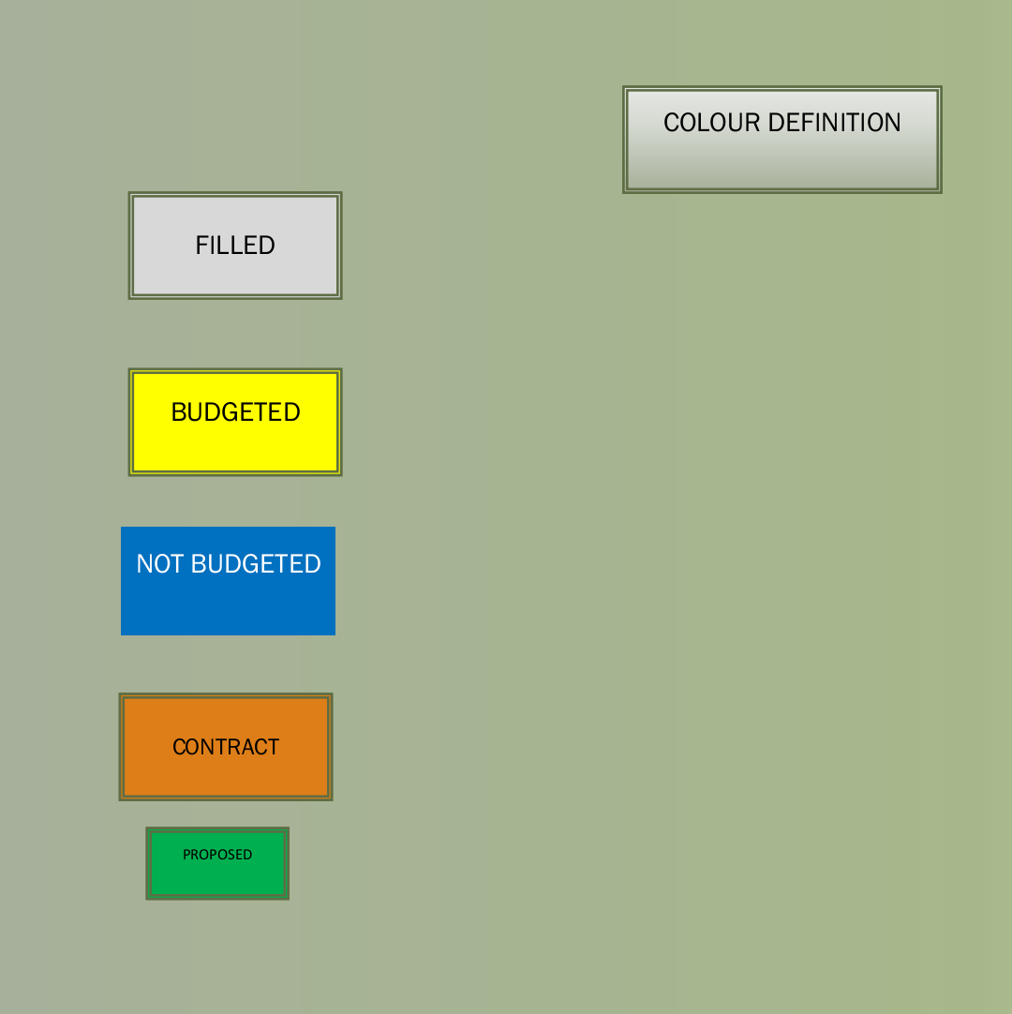
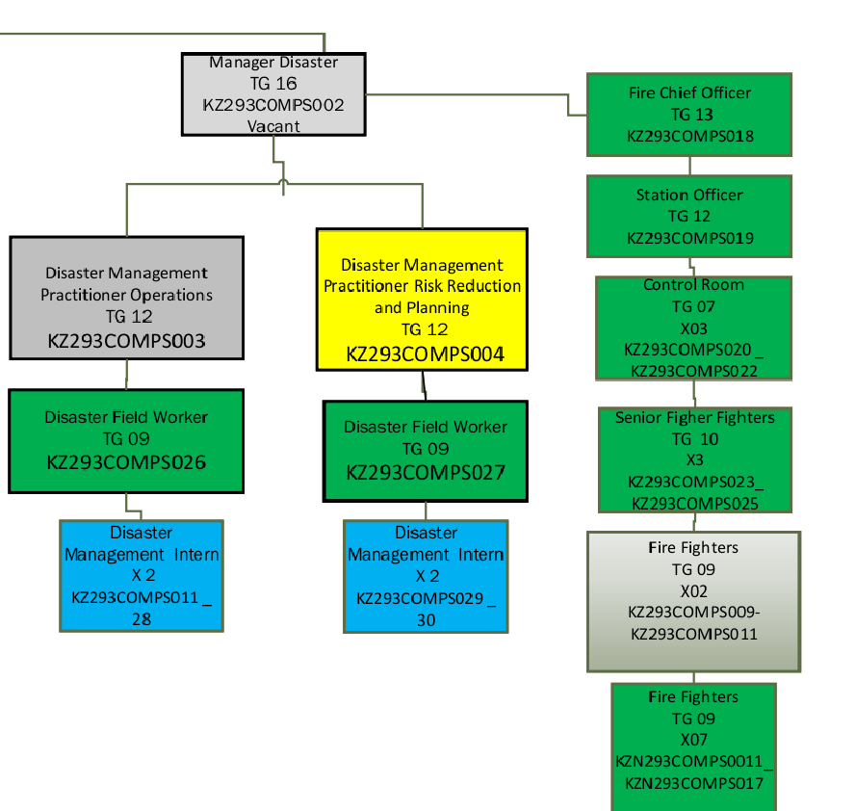

Figure 1. The above structure is the proposed organogram of Disaster and Emergency services.

Status of Municipal Disaster Management Centre (DMC)
Ndwedwe Local Municipality does not have a Disaster Management Centre, however there is a satellite Disaster Management Office that is functional and implements disaster management related activities. The office is located at the Ndwedwe Local Municipal offices situated on Lot 47-48, Road P100. In terms of personnel for the Disaster Management Function, Ndwedwe Local Municipality has permanently employed one Manager-Disaster Management.
A stand-alone building accommodating Disaster Management and Fire Services is required in order to fully comply with the Minimum Infrastructural Requirements for Disaster Management Centers that are recommended by the National Disaster Management Centre.

Status of Fire & Rescue Services
Ndwedwe Local Municipality has secured a suitable land for the construction of Disaster and Emergency Services Centre to accommodate both Disaster management and Fire Services. Currently, the Municipality only has two fully fledged fire and rescue vehicles equipped to perform fire and rescue functions. Both these vehicles are utilized as first responders to reported fire and rescue incidents. In terms of human capacity, the municipality has permanently employed 2x Fire Fighters and five interns.

Status of Municipal Disaster Management Policy Framework
The Disaster management framework of the Municipality was adopted by the Council on March 2022. Ndwedwe Local Municipality will be reviewed in 2026/2027 financial year.

Status of Municipal Disaster Management Plan
There is a complete Level 1 disaster management plan adopted by Council in the fiscal year 2022/2023. According to the Disaster Management Act, the disaster management plan must be evaluated regularly.

Municipal Disaster Management Inter-Departmental Committee
Management Committee is a high level decision making structure within the municipality where all departments meet on monthly basis to discuss council business and Disaster Management forms part of issues for discussion during these meetings. These are internal departments who participate in Management Committee:
- Technical Services
- Community and Social Services
- Cooperate Services
- Finance
- Economic Development

Community and Social Services Portfolio Committee.
Community and Social Services and Portfolio Committee is a political oversight in all matters related to community and social services. Its mandate is to ensure accountability and take decisions on Disaster Management, Fire and Rescue Services issues. The Portfolio Committee meets on monthly basis to discuss Disaster Management, Fire and Rescue Services issues.

Municipal Disaster Management Advisory Forum (DMAF)
The Ndwedwe Municipal Disaster Management Advisory Forum has been established and is fully functional. The forum meeting sits once within a quarter as per requirements by the Disaster Management Act 57 of 2002. Challenges experienced with the seating of these forum meetings is that attendance of Sector Departments is not satisfactory. The Disaster Management Unit will identify focal points within each (relevant) department and create a good working relationship with those identified stakeholders.

Critical stakeholders are departments that form part of advisory forum and those whom we share the same responsibility in terms of response and recovery. Those stakeholders are as follows;

- South African security agency
- Department of social development.
- Technical services
- Department of health
- South African Weather services.
- Boxer supers store.
- Red cross
- Provincial Disaster Management Centre
- District Disaster Management Centre
- Department of Transport
- Agriculture
- Traditional Leadership

Disaster and Emergency Services SWOT Analysis
Table 1: Disaster Management: SWOT Analysis

Strengths  - Disaster Management Plan is in place.  - Disaster risk assessments have been conducted.  - Political buy in, support and interest in disaster management and Fire issues is being established.  - Budget allocation for disaster relief.  - One dedicated disaster vehicle is in place.  - Two Fire and Rescue vehicle is in place  - Designated and permanently employed Disaster Management Manager.  - Well established institutional dispositions such as advisory forum and portfolio committee meetings.  - Two Fire Fighters permanently employed.  - Five Fire Fighter Interns employed. | Weaknesses  - Non-existence of the Disaster and Emergency Centre including Fire Station.  - Lack of relevant protective clothing and relevant fire kits.  - Lack of effective link and communication of disaster information to the public.  - Limited funding for emergency relief and risk reduction activities.  - Poor attendance of Stakeholders to Advisory Forum.  - Lack of Disaster Management and Fire Fighting Capacity.
Opportunities  - Establishment of a Fire Service Station and satellite stations.  - Enhanced local investments and economic growth.  - Proactive and preventative measures such as early warning detectors.  - Improved, response, recovery and rehabilitation.  - Installation of lightning conductors.  - Volunteer establishment  - Impactful awareness campaigns and capacity building programs.  - Employment of Disaster Management and Fire Personnel. | Threats  - Loss of life and injuries.  - Damage to property and infrastructure  - Severe effects of climate change  - Alien weed growth which excavates water shortages.  - Loss of life stock and crops  - Increase of structural fires.  - Protests.  - Inadequate budget for Disaster Management and Fire and Rescue Services.

Challenges for Disaster Management, Fire and Rescue Services as per SWOT Analysis
In addition to above SWOT Analysis, some concerns by Ndwedwe Local Municipality are listed in a table below:
Table 2. State the challenges and interventions that are recommended to improve the certain conditions.
Challenges | Interventions/recommendations
- Lack of operational work space for Disaster Management, Fire and Rescue Services. | - Construction of Disaster and Emergency Services Centre.
- Lack of Disaster Management and Fire Fighting Capacity. | - Recruitment of additional personnel for Disaster Management, Fire and Rescue Services.
- Lack of effective link and communication of disaster information to the public. | - Establishment of volunteer unit.  - Intensify awareness programs.  - Use of SMS system, loud hailing, WhatsApp as communication instruments with the public.
- Lack of personal protective clothing and equipment. | - Procurement of protective clothing and equipment for personnel.
- Poor attendance and reporting by other sector departments and role players. | - Engage Sector departments and formalize their membership to the Forum.
- The municipality is not in compliance with disaster management turnaround response time due to lack of human capacity and working equipment. | - Employment of more personnel, additional of resources/tools of trade, exploring standby allowances and overtime for employees.
- Lightning remains the municipality’s most dangerous incident as it includes injuries and loss of lives/livestock | - Installation of lightning conductors in high vulnerable households.  - Intensify public awareness programs.  - Engage agriculture and develop community based program responsive to livestock lost due to lightning strikes.
- Fire hazard remains the most dominant | - Increase capacity personnel within the unit in order to have a proactive response  - Establishment of Disaster and Emergency Services that will deal with fire incidents precisely.  - Fully functional Fire and Rescue Service.
- Severe and uncontrollable impacts of climate change. | - Conduct quarterly Disaster Management workshops with ward councilors, community members, religious leaders and traditional leaders about climate change and they can circulate the knowledge to the people.

KEY PERFOMANCE AREA 2: DISASTER RISK ASSESSMENT
The Acts requirements for priority setting with respect to disasters likely to affect South Africa are set out in sections 20, 33 and 47. Key performance area 2 outlines the requirements for implementing disaster risk assessment and monitoring by organs of state within all spheres of government.

List of Priority Risks in Ndwedwe Local Municipality are as follows;
HAZARDS |  | LOCATION
Fire (Structural and Veld Fires) | In all Wards
Severe weather:
- Lightning | In all Wards (mostly in wards 5, 9, 15, 16 and 18)
- Strong winds | In all Wards
- Hailstorms | In all Wards
- Heavy rain | In all Wards
- Structural Fire | In All Wards (mostly in wards 11, 12, 13, 15, 17 and 19)
➢ Extreme temperatures | In all Wards
 | In all Wards
Accidents (MVAs) | Mostly on P100 and R614
Drowning | Riverbanks, streams and man-made dams
Illegal Electricity Connection | In all Wards

The risk severity rating.
High | Red
Moderate | Yellow
Low | Green

Hazard Maps
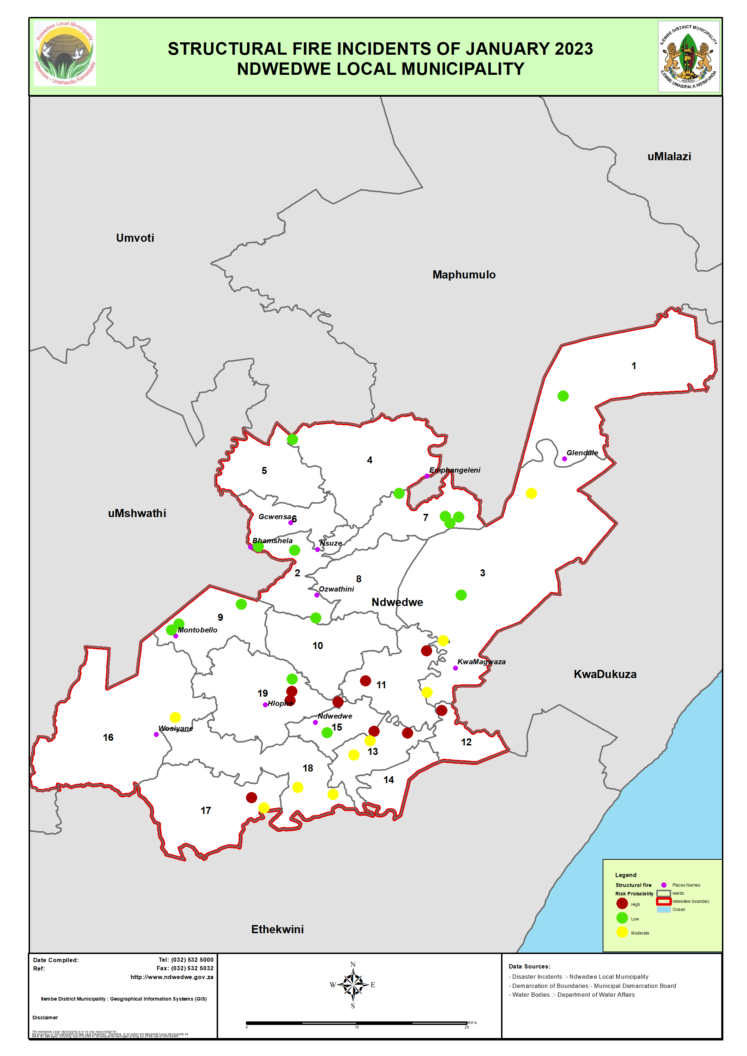

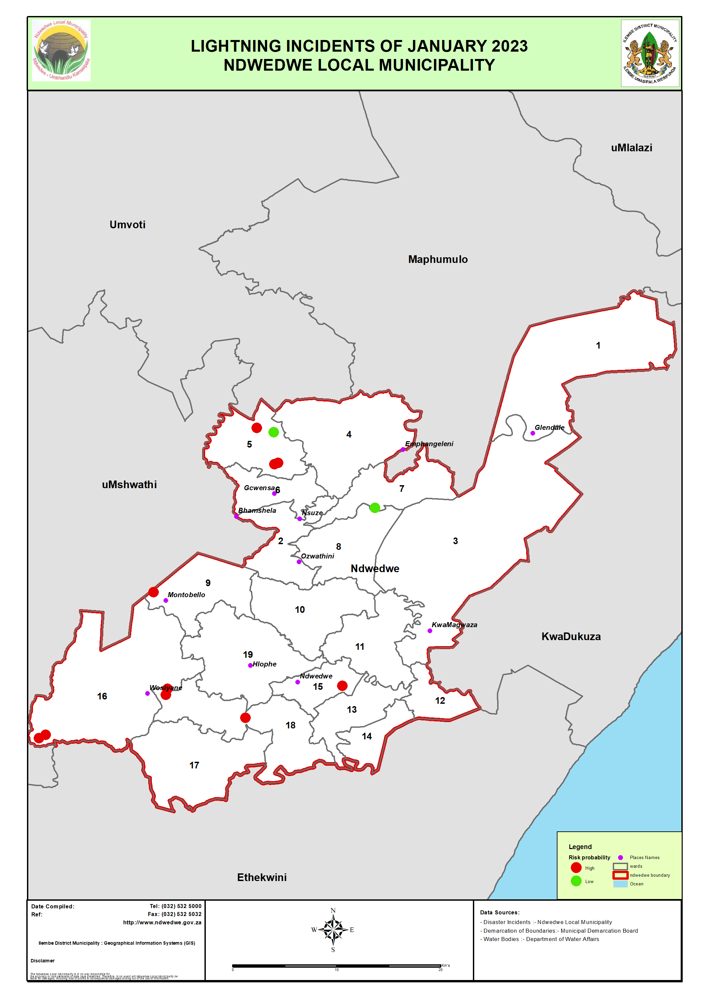

  - Critical Community Structures
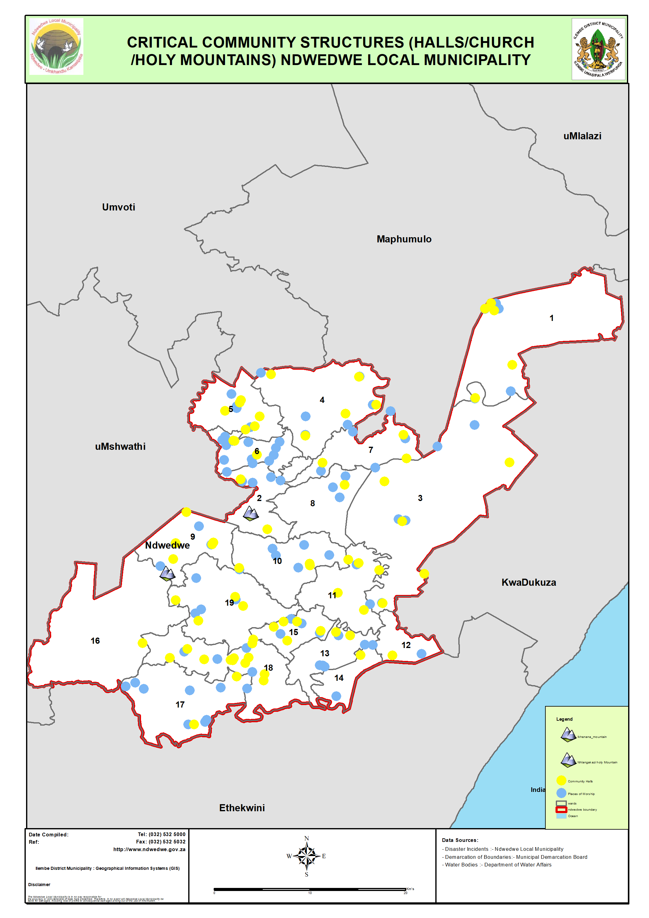

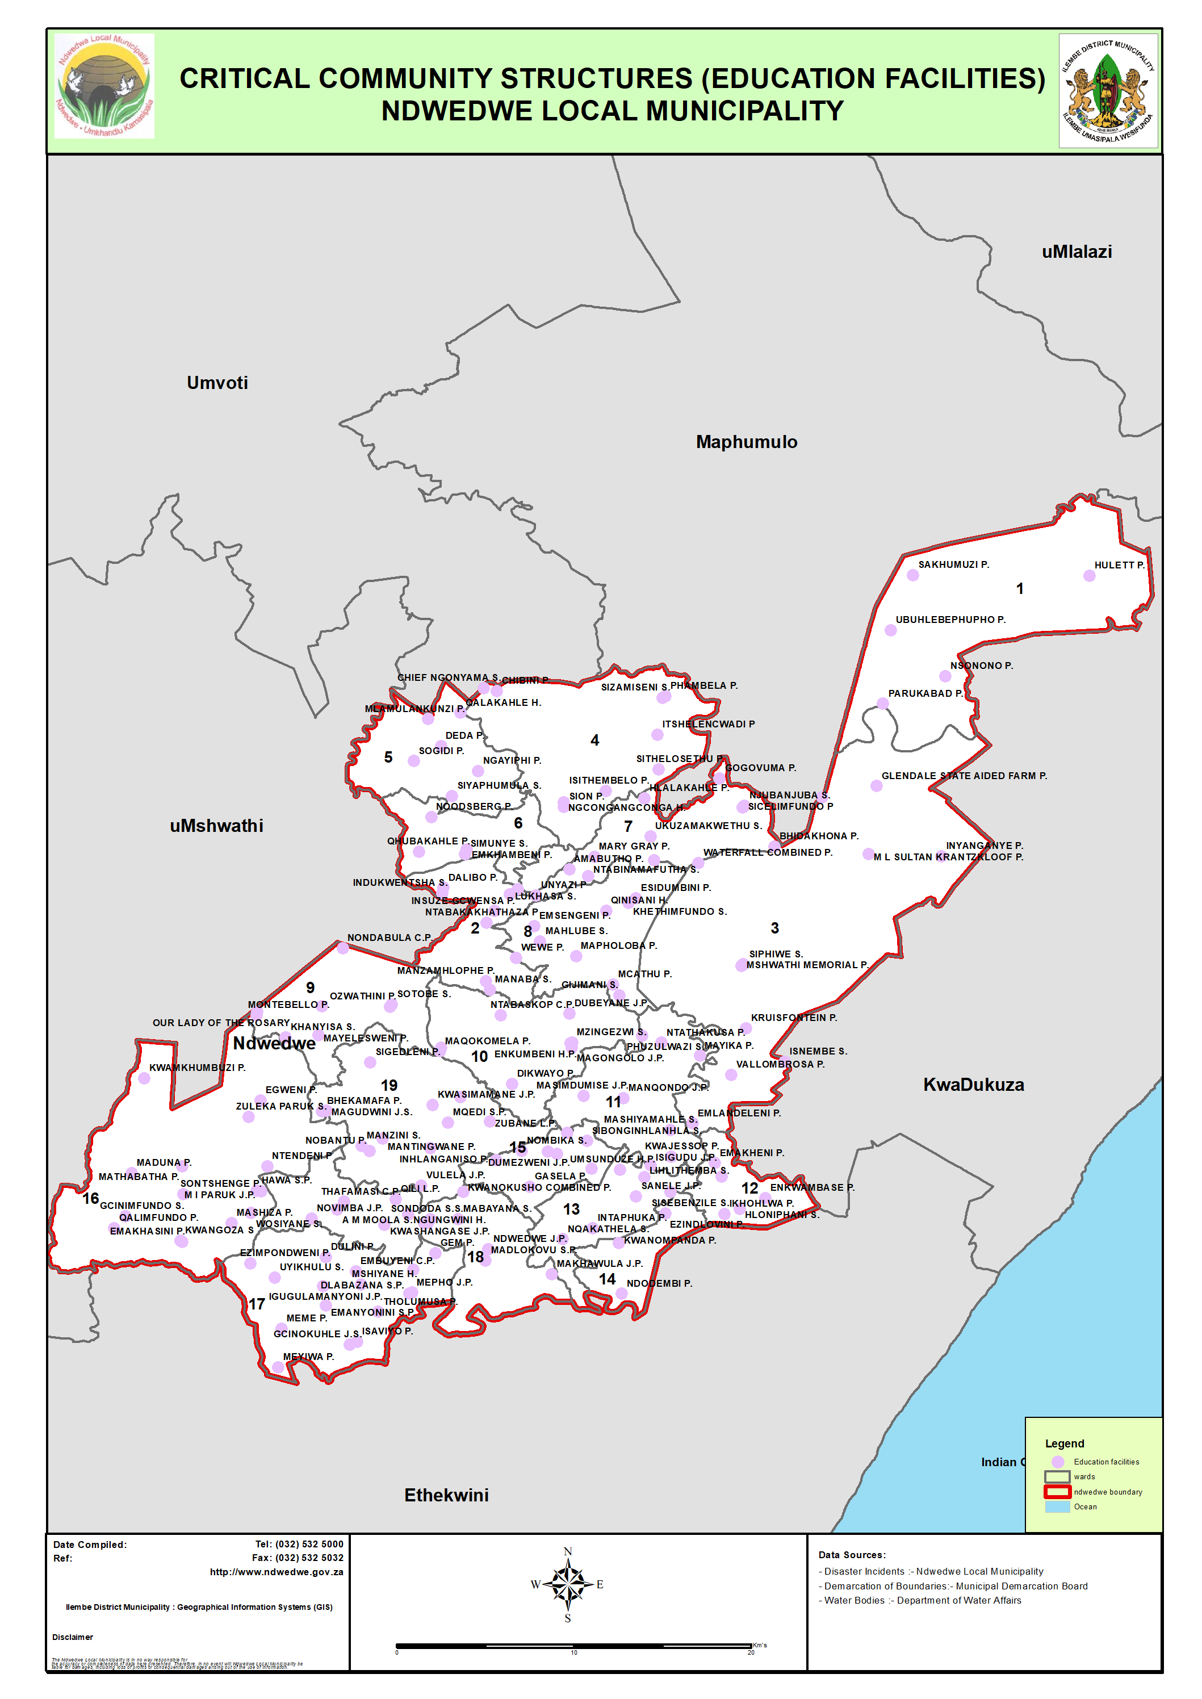

Overall Risk Map.
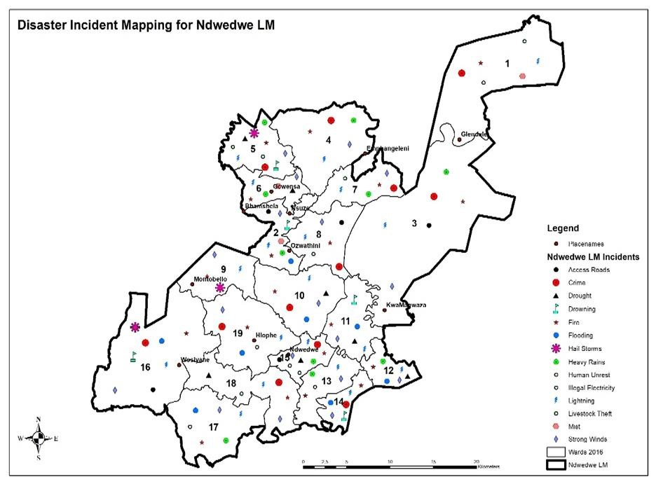

Analysis of Climate Change Risks

RISK | SECTOR |  | IMPACTS
Severe thunderstorm | DOT |  | Damages to Roads and Bridges.
Severe thunderstorm | Health |  | Loss of human life and injuries
Lightning | Health |  | Loss of human life and injuries.  Increase of diseases
Lightning | DHS |  | Damage to households and household contents
Lightning | Agriculture |  | Livestock and crop damages
Drought | Health |  | Loss of life and injury
Drought | Agriculture |  | Alien plants growth  Loss of livestock and crops
Drought |  |  | Loss of rivers and wetlands
Food security | Agriculture |  | Unsatisfactory production levels
Environment |  |  | Biodiversity  Vegetation
Flooding / Heavy rainfall | Health |  | Loss of life
Flooding / Heavy rainfall | DHS |  | Households being submerged in water.  Household content being damaged.
Flooding / Heavy rainfall | Agriculture |  | Land degradation  Livestock and crop damages.  Siltation and soil erosion.

KEY PERFOMANCE AREA 3: DISASTER RISK REDUCTION
The successful implication of this KPA critically depends on the preparation and alignment of disaster management frameworks and plans for all spheres of government. The Key performance area 3 addresses requirements for disaster risk management planning within Local government.

Plans for Disaster and Emergency Service Centre
Ndwedwe Local Municipality is planning to establish the Disaster and Emergency Services. The municipality have applied for funding and the application is currently in process. Community leaders have given enough land where the unit will be building the Disaster and Emergency Services and they are waiting for funding application to be approved so that the process will start.

    - PROPOSED ACTION PLAN FOR THE CONSTRUCTION OF DISASTER AND EMERGENCY SERVICES.
KEY ACTIVITY |  |  | TIMEFRAMES
Development of Terms of Reference |  |  | May 2023
Prepare tender document for appointment of project manager |  |  | May 2023
Evaluation and Adjudication |  |  | May 2023
Appointment of Project Team |  |  | May -June 2023
Registration of land (PTO) |  |  | June 2023
Environmental 1m act Assessment |  |  | July 2023
Detailed Business Plan & implementation pIan |  |  | July 2023
Conceptual Designs and Layouts |  |  | July 2023
Bill of Quantities & Tender Documents |  |  | August 2023

 | Approval of Tender Documents |  | September | 2023
Tender Advert for Contractor |  |  | September | 2023
Evaluation and Adjudication |  |  | October | 2023
 | Appointment of Contractor |  | November | 2023
Site Handover |  |  | November | 2023
Site Establishment |  |  | November | 2023
Commencement of Construction |  |  | December | 2023
Actual Construction |  |  | December 2024 | 2023
Project Completion |  |  | May 2024
Official hand-over of Ndwedwe emergency Management Centre |  |  | June 2024

Programs with stakeholders
Ndwedwe Local Municipality holds workshops twice a quarter where by all stakeholders are invited to sit and have an input about how they plan to support the communities and how far are they willing to help. Stakeholders are also part of response projects since they are the ones who donates a lot of relief material when the Municipal responds to disasters.

Disaster and Fire services projects/programs with proposed budget 2023/2024.
No. | PROJECT | BUDGET | Timelines | TARGET | RESPONSIBLE
 | Disaster Awareness campaigns | 100 000.00 | 4 per quarter | Schools  Community | Mr. T. Ngiba
 | Advisory forums | 100 000.00 | 1 per quarter | Stakeholders | Mr. T. Ngiba
 | Capacity building | 80 000.00 | 2 per quarter | Community Leaders( Traditional Leaders, Ward Councilors, etc.) | Mr. T. Ngiba
 | Emergency Relief Aid | 450 000.00 |  | ( Blankets, Sponges, Plastic Sheeting, Box B, Food Vouchers) | Mr. T. Ngiba
 | Lightning conductors | 450 000.00 | Five per quarter | Vulnerable Community | Mr. T. Ngiba
 | Disaster and Emergency Services Establishment | R15 m |  |  | Mr. DSG Khuzwayo (Municipal Manager)
7. | Fire fighters Protective clothing | 500 000.00 |  | Stuff | Mr. T. Ngiba
8. | Fire Fighting Equipment | 350 000.00 |  | (type of equipment) | Mr. T. Ngiba
9. | Staff uniform | 300 000.00 |  |  | Mr. T. Ngiba
10. | Promotional material | 250 000.00 |  | (umbrellas, ceramic cups, pencil cases) | Mr. T. Ngiba
11. | Extrication tools (service) | 100 000.00 |  |  | Mr. T. Ngiba
12. | Climate change adaptation strategy | 100 000.00 |  | Vulnerable Communities | Mr. T. Ngiba
13. | Fire safety awareness campaigns | 60 000.00 | 2 per quarter | Schools and Communities | Mr. T. Ngiba
14. | Building material vouchers | 450 000.00 |  | Casualties | Mr. T. Ngiba
15. | Trainings | 200 000.00 |  | Staff | Mr. T. Ngiba
16. | Disaster & Emergency Unit Park home offices | 800 000.00 |  | Unit | Mr. T. Ngiba
17. | Meetings and Conferences | 100 000.00 |  | Staff | Mr. T. Ngiba
18. | Disaster Management Workshops | 80 000.00 | 2 per quarter | Municipal officials, traditional leaders and stakeholders | Mr. T. Ngiba
19. | Youth taking front row in Disaster Management | 80 000.00 |  | Youth | Mr. T. Ngiba
20. | Role of women in Disaster Management | 80 000.00 |  | Women | Mr. T. Ngiba
 | Total | 19 630 000 |  |  | Mr. T. Ngiba

  - Department of Human Settlements
Project | Budget | Target | Responsible Person
- Building of Houses | _ | All wards | Mr. S Gumede
- Repairs of Houses | _ | All wards | Mr. S Gumede

KEY PERFORMANCE AREA 4: DISASTER RESPONSE AND RECOVERY
This KPA requires an integrated and coordinated policy that focuses on rapid and effective response to disasters and post disaster recovery and rehabilitation. This section addresses key requirements that will ensure that planning for disaster response and recovery as well as for rehabilitation and reconstruction achieves these objectives.

Damage assessment.
Disaster and Emergency Services Unit continue responding to disasters, assess them, and document their such incidents and responses, the turnaround time is three hours. Thorough assessment is conducted and then emergency relief aid materials are distributed based on each victim's urgent needs. Reports and beneficiary lists are compiled and shared with District Disaster Management Centre.

Rehabilitation
Relevant rehabilitation and recovery measures are undertaken from relevant sector departments such as Human Settlement (housing), South African Social Security Agency (food vouchers), Social Development (counselling and food vouchers) and Department of Health (medical needs). The Unit than install lightning conductors to those households that are victims of lightning.

Municipal Capacity in terms of Response and Recovery.
- Ndwedwe Local Municipality is in the process of establishing the Disaster and Emergency Services. The municipality has procured relevant working equipment. Those developments will equip the Fire and Rescue personnel to respond promptly to reported disaster occurrences.
- The Disaster personnel was provided with resources through which incidents can be reported and attended too. Once an incident is reported, the team attends to the affected area to conduct assessments and provide relief and or feedback as may be required.
- The Disaster and Emergency Services Unit plans to recruit ten volunteers on each ward.
- Councilors, Ward Committees, Amakhosi and Izinduna remain our important pillar in providing information during response and recovery processes.

Funding allocated for post-disaster recovery.
The Municipality has a set aside meager budget for post-disaster recovery grant that is also jerked up by interventions from other sector departments like Department of Social development, SASSA and Human Settlements.
  - List of Relevant Stakeholders
The following is the list of relevant role players in disaster response and recovery.
INSTITUTION | CONTACT PERSON | CONTACT DETAILS | EMAIL ADDRESS
Ndwedwe Local Municipality Disaster and Fire Services | Mr. T. Ngiba | 060 584 5048 | Ngibapv@gmail.com/  Thetha.Ngiba@ndwedwe.gov.za
Ndwedwe Local Municipality Disaster and Fire Services | Mr. MD. Goqo | 079 741 5005 | dalokuhlemlondi@gmail.com  Dalokuhle.Goqo@ndwedwe.gov.za
Ndwedwe Local Municipality Disaster and Fire Services | Mr. ME. Luthuli | 060 968 3006 | Mncengeni.Luthuli@ndwedwe.gov.za
Ndwedwe Local Municipality Disaster and Fire Services | Mr. ZC. Mkhize | 060 968 2951 | Zama.Mkhize@ndwedwe.gov.za
iLembe Disaster Management Centre | Mr. S. Ngubane | 071 879 7155 | Sifiso.Ngubane@ilembe.gov.za
iLembe Disaster Management Centre | Mr. B. Mkhize |  | Bhekimkhize@ilembe.gov.za
Provincial Disaster Management  Centre | Mr. B. Phungula | 072 512 8601 | Bheki.Phungula@kzncogta.gov.za
Provincial Disaster Management  Centre | Mrs. T. Mkhize | 078 647 9660 | Thandeka.Mkhize@kzncogta.gov.za
Ndwedwe Technical Services | Mr. F. Luthuli | 060 967 1811 | Fortune.Luthuli@ndwedwe.gov.za
ILembe Technical Services | Mr. E. Bhengu | 083 562 8292 | Ellias.Bhengu@ilembe.gov.za
Ndwedwe SASSA | Mr. M. Mthembu | 083 412 8888 | mbongenijm@sassa.gov.za
Bhamshela SASSA
Ndwedwe Department of Social Development | Ms. X. Shange | 072 102 8563 | Xolileshange@kzn.gov.za
Bhamshela Department of Social Development | Mrs. Z. Blose | 063 649 1752  072 555 1737 | blosezuziwe@gmail.com
Ndwedwe South African Police Service | Ms. P. Simamane | 061 057 5943 | Kzn:ndwedwesaps@saps.gov.za
Nsuze South African Police Services | Mr. PM. Msomi | 061 286 9661 | Masomini4@gmail.com
Glendale South African Police Services | Captain Mnguni | 082 417 8824 | GumedeE@saps.gov.za
Department of Transport | Mr. Sibisi | 082 808 2758
Department of Human Settlement | Mr. L. Moonsamy | 082 771 5029 | Lenny.Moonsamy@kzndhs.gov.za
Department of Education | Mr. AJ. Msane | 081 556 8177
Department of Health | Dr. Ayeni | 083 300 9877
Department of Agriculture | Mr. Khumalo | 082 461 8341 | Khumalo.Kwazi@gmail.com
Emergency Medical Rescue Services | Mr. L. Doransamy | 083 991 6232 | lenny.dorasamy@kznhealth.gov.za
Environmental health | Mr. Xulu | 078 829 0568
Al Imdaad | Mr. A. Karrim | 082 587 8602
South African Weather Service | Wisani Maluleka | 078 166 2172
Working on Fire | Ms. M. Dladla | 071 888 5374 | Makhosi.Dladla@wofire.co.za
Ndwedwe Communication | Mr. Victor | 060 773 0309 | Victormalusi24@gmail.com
Ndwedwe Traditional Affairs | Mr. S. Khumalo | 076 320 8266 | Khumalo.sbongseni85@gmail.com

ENABLER 1. INFORMATION MANAGEMENT AND COMMUNICATION
Integrated disaster risk management depends on access to reliable hazard and disaster risk information as well as effective information management and communication systems to enable the receipt, dissemination and exchange of information.

Information management
Ndwedwe Local Municipality is in the process of establishing a Disaster Management Centre with a fully fleshed information management and communication system that will meet the requirements of the National Disaster Management Framework. Ndwedwe Disaster and Emergency Services Unit has access to computer and communication system and is able to perform the following: capturing (letters, minutes, memo’s, pictures and assessment forms), storing (record and filing), emailing and delivering the right information to the relevant authorities at the right times. The Municipality deals with disaster management information sharing through monthly, quarterly and annual reports that are compiled and submitted accordingly.

Disaster Management Committees
Furthermore, engagements with other existing structures within the municipality such as Operation Sukuma Sakhe (OSS) are used to share disaster information. The Disaster Management Practitioners and Advisory Forum meetings at Local, District and Provincial levels are another platform for information sharing.

Communication system
An operational communications system (control room) for municipal emergency services has not yet been established. As required by the National Disaster Management Framework- Enabler 3, Ndwedwe Local Municipality is a conduit and repository for information on disasters and impending disasters. It is for this reason that Ndwedwe Local Municipality must develop a 24hour Operational Communication System (OPS) and office that will be used to log, capture and monitor all reported disaster incidents. This communication system must include an emergency hotline contact number and a dedicated personnel through which community members report incidents.

Early Warning Strategy
Early warnings are received from iLembe District in a Practitioner’s WhatsApp group. Ndwedwe Local Municipality uses its Facebook page, WhatsApp groups, local radio station (Siyathuthuka Radio Station), loud hailing and other platforms for cascading early warning information to its stakeholders.

Plans for Information management & communication system in next financial year
The municipality aims to strengthen its communication platforms including the short messaging service (SMS) system that is already in existence to distribute early warning.

ENABLER 2. EDUCATION, TRAINING, PUBLIC AWARENESS AND RESEARCH.
Sections 15 and 20 (2) of the acts specify the encouragement of a broad-based culture of risk avoidance, the promotion of education and training throughout the republic, and the promotion of research into all aspects of disaster risk management. This enabler addresses the requirements for the development and the implementation of a national education, training and research needs and resources analysis and a national disaster risk management education and training framework.

Planned Capacity Building Programs
PROGRAM | BUDGET | TARGET AUDIENCE | TIMELINES
1. Integration of Indigenous Knowledge to Disaster Management (Traditional  Leaders Workshop) | 20 000 | All Amakhosi and Izinduna | 1st quarter
2. Training of Ward  Committees | 10 000 | All 200 Municipal  Ward Committee Members | 4th quarter
3. Launch of Disaster  Management Volunteers | 30 000 | 150 Volunteers | 4th quarter
- War room Stakeholders | 20 000

Planned Public Disaster Awareness Campaigns
PROGRAM | BUDGET | TARGET AUDIENCE | TIMELINES
Awareness Campaigns | 100 000 | Communities, Schools, Informal Settlements, Child headed households, People living with disabilities, clinics, and senior citizens | - per quarter

Planned fire safety awareness
PROGRAM | BUDGET | TARGET AUDIENCE | TIMELINES
Fire safety awareness campaign | R60 000 | Communities, Schools, Informal Settlements, Child headed households, People living with disabilities, and senior citizens | 2 per quarter

Research
Currently the Municipality has no research funding. The research is done internal by the interns of which it is ward based concerning the risk profiling.

Education and training programs

Ndwedwe local Municipality plans to continue taking students from various tertiary institutions for in-service training program that was established in 2021/2022 financial year.

ENABLER 3. FUNDING ARRANGEMENTS FOR DISASTER RISK MANAGEMENT.
Section 7 (2) of the Act requires that the national disaster management framework makes provision for a framework within which organs of state may fund disaster risk management with specific emphasis on preventing or reducing the risk of disasters, including grants to contribute to post disaster recovery and rehabilitation and payment to victims of disaster and their dependents.

Breakdown of available budget for disaster management and fire services.
No. | PROJECT | Source of Funding | BUDGET | RESPONSIBLE
 | Awareness campaigns |  | 100 000 | Mr. T. Ngiba
 | Advisory forums |  | 100 000 | Mr. T. Ngiba
 | Capacity building |  | 80 000 | Mr. T. Ngiba
 | Emergency Relief Aid |  | 450 000 | Mr. T. Ngiba
 | Lightning conductors |  | 450 000 | Mr. T. Ngiba
 | Disaster and Emergency Services Establishment | Internal and External (COGTA) | 15 m | Mr. DSG Khuzwayo (Municipal manager)
7. | Fire fighters Protective clothing |  | 500 000 | Mr. T. Ngiba
8. | Fire Fighting Equipment |  | 350 000 | Mr. T. Ngiba
9. | Staff uniform |  | 300 000 | Mr. T. Ngiba
10. | Promotional material |  | 250 000 | Mr. T. Ngiba
11. | Extrication tools |  | 100 000 | Mr. T. Ngiba
12. | Climate change adaptation strategy |  | 100 000 | Mr. T. Ngiba
13. | Fire safety awareness campaigns |  | 60 000 | Mr. T. Ngiba
14. | Disaster building material voucher |  | 450 000 | Mr. T. Ngiba
15. | Trainings |  | 200 000 | Mr. T. Ngiba
16. | Disaster & Emergency Park home offices |  | 800 000 | Mr. T. Ngiba
17. | Meetings and Conferences |  | 100 000 | Mr. T. Ngiba
 | Total |  | R19 390 000 | Mr. T. Ngiba

Funding Mobilization Strategy
The Ndwedwe Disaster and Emergency Services Unit receives its budget allocations from the municipality’s annual budget in order to implement its functions.
Funding for the establishment of an emergency center that will incorporate both fire service and disaster management has been sourced.

Private Partnerships
The Municipality does not have formal partnerships and/or receive donations and sponsorships from any private institution.

