Appendix T: National and Provincial Outcome for Local Government

The Ndwedwe Local Municipality has embarked on a process to review and refine its plans in the context of changing needs and new developments within the Municipality. Ndwedwe Municipality Five (5) Year strategic objectives have been aligned into National Outcomes,
Sustainable Development Goals (SDG’s) Provincial Growth and Development Strategy (PGDS), and iLembe Regional Spatial Development Plan (IRSDP) as shown in the Table below.

DEVELOP A RESILIENT LOCAL ECONOMY THAT CREATES SUSTAINABLE DECENT JOBS AND REDUCES POVERTY THROUGH THE FOLLOWING:
- Review institutional arrangements appropriate for the achievement of local economic development objectives;
- Create municipal capacity to implement projects identified in each economic sector;
- Facilitate municipal support programmes for the same and cooperatives
FACILITATE SPATIAL ALIGNMENT AND COORDINATION THROUGH RESPONSIBLE DEVELOPMENT THAT IS SENSITIVE TO SUSTAINABLE ENVIRONMENTAL MANAGEMENT AND CONSERVATION:
- Facilitate the finalization Ndwedwe town establishment programme;
- Facilitate the implementation of sustainable environmental programmes to support green economy;
- Create appropriate institutional environment for the implementation of LUMS and SDF principles, especially in areas of Ingonyama Trust Board (ITB).

ENSURE MUNICIPAL FINANCIAL VIABILITY THROUGH: Operation clean audit
- Grap compliant annual financial statements – the municipality should have sufficient capacity from within to be able to prepare fully grap compliant annual financial statements.
- Grap compliant fixed assets register – controls should be put in place to ensure that the asset register is complete, with supporting documents, and is fully grap compliant.
- Compliance with laws and regulations – a checklist of all laws and regulations that need to be complied with needs to be developed to assist the municipality to ensure compliance therewith.
REVENUE ENHANCEMENT STRATEGY:
- Credit control policy – the Municipality will need to review and implement its credit control policy to ensure that the revenue base is improved in order to help the Municipality to develop financially.
- Municipal Property Rates Act – new valuation roll, rates by-laws and rates policy must be finalised before start of new financial year, 1 July 2015, so that the Municipality can rate and collect revenue in 2015/2016 financial year, going forward.
- Traffic department – the Municipality must start processes of engaging with Provincial Department of Transport, to get approval for opening and running a traffic department on their behalf, so as to generate more revenue for the Municipality, to assist with further development.

RE-ALIGNMENT OF FINANCE ORGANOGRAM TO ENABLE IT TO ACHIEVE STRATEGIC DEVELOPMENT OBJECTIVES
- Review Finance Organogram – Finance department’s organogram needs to be reviewed to ensure that the department is sufficiently staffed to perform its function effectively.
- Minimum competency – the Municipality will need to ensure that all staff members within Finance department have minimum competencies as prescribed by National Treasury in order to ensure that competent staff members are employed and retained for a more efficient service delivery.

PROMOTE GOOD GOVERNANCE AND PUBLIC PARTICIPATION THROUGH:
- Conducting quarterly and annual assessments of ward committees;
- Filling the vacant position of communications manager to attend to improve communication with internal and external stakeholders; and
- Conducting continuous assessments regarding the functionality of all municipal structures.

FACILITATE THE PROVISION OF SUSTAINABLE BASIC SERVICE DELIVERY THROUGH:
- The filling of vacant posts which are critical for the directorate to implement its infrastructure programmes, especially its expenditure on MIG;
- Facilitating the eradication of backlogs on household infrastructure services, especially electricity.

FACILITATE INSTITUTIONAL TRANSFORMATION AND ORGANIZATIONAL DEVELOPMENT THROUGH:
- the progressive re-alignment of the municipality’s organogram to fit in with its vision and strategic objectives;
- filling in all critical positions to ensure municipal stability and improved service delivery; and
- addressing gender and employment equity through the recruitment processes of the municipality

National Development Plan

In 2011 the National Planning Commission (NPC) conducted a diagnosis of the challenges facing South Africa. This process culminated to the NPC producing a Diagnostic Report which report highlighted critical challenges facing the people of this country from joblessness, poor education, disease burden health, corruption etc. The situation that the country finds itself has had an effect of leaving the majority of the population trapped in a vicious circle of poverty and a growing gap of the haves and those that have not. See the figure 3 below. To arrest this situation, the NPC has developed a 20-year National Development Plan (NDP).

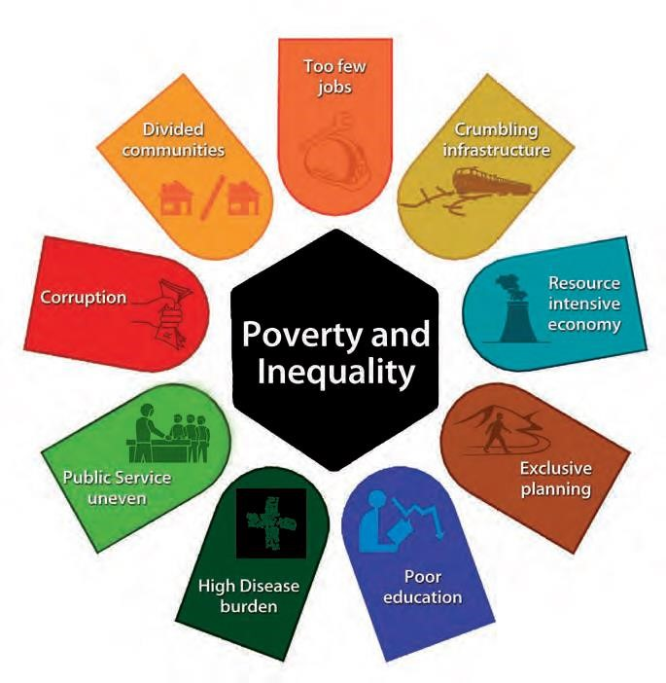

Figure 1: Poverty and inequality

a) What Does the National Development Plan Propose?

The point of departure for the NDP is fighting poverty and inequality in South Africa. According to the NPC South Africa can eliminate poverty and reduce inequality by 2030. It will require change, hard work, leadership and unity. The main goal is to improve the life chances of all South Africans, but particularly those young people who presently live in poverty. The plan helps to chart a new course. It focuses on putting in place the things that people need to grasp opportunities such as education and public transport and to broaden the opportunities through economic growth and the availability of jobs. Everything in the plan is aimed at reducing poverty and inequality. See figure 4 below

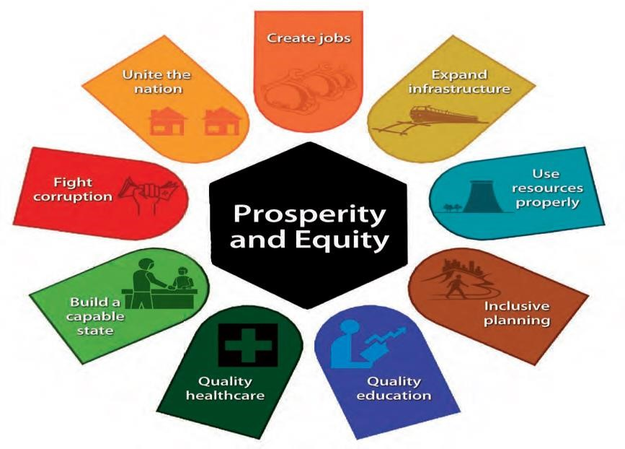

Figure 2: Prosperity and Equity

The National Development Plan seeks to address the triple challenge of poverty, unemployment and inequality through the following programmes (which themselves have various proposed specific interventions):
- Job creation (target of 11 million jobs by 2030)
- Expanding infrastructure
- Transition to a low-carbon economy
- Transform urban and rural spaces
- Education and training
- Build a capable state
- Fight corruption
- Provide quality health care
- Transformation and unity

The Ndwedwe Local Municipality has attempted to initiate programmes and projects that will enable it to contribute towards the realization of the NDP goals and targets. For example, the municipality is currently facilitating the Community Works Programme and Expanded Public Works Programme that have created 1200 and 100 job opportunities, respectively. In terms of transforming urban and rural areas, the municipality has focused more on attracting both public and private investors into the nodal areas of Bhamshela and Ndwedwe as well as its development corridors with the long-term objective of bring sustainable economic development that triumph against poverty, unemployment and inequality.

Provincial Developmental Strategic Goals

The Provincial Growth and Development Strategies have a crucial role to play in giving effect to government`s concept of a developmental state, through:
- Growing Economy
- Reducing Unemployment
- Eradicating Poverty
- Ensuring greater social inclusion and cohesion

The Cabinet took a decision to priorities six KZN Government priorities for development in order to grow the economy of the province:
- Strengthening governance and service delivery
- Sustainable economic development and job creation
- Integrating investments in community infrastructure
- Developing human capability
- Developing a comprehensive response to HIV/AIDS
- Fighting poverty and protecting vulnerable groups in society

Ndwedwe Local Economic Development Strategy is aligning to the above six priorities for KZN Government.

Provincial Growth and Development Plan

The PGDP is a plan formulated with the objective to translate the PGDS into an implementation plan which will provide a sound platform for departmental, sectoral and stakeholder annual performance planning and therefore to guide resource allocation. The focus is on driving implementation in a coordinated and integrated manner, where progress can be measured against predetermined targets and where roles and responsibilities have been confirmed within established lines of accountability through:

- Inclusive economic growth
- Huma resources development
- Human and community development
- Infrastructure development
- Environmental sustainability
- Governance and policy
- Spatial equity

District Growth and Development Plan (DGDP)

The iLembe District Municipality Council adopted the iLembe Regional Spatial Development Plan (IRSDP) in 2013. This document essentially provides a blueprint for the District to become a “sustainable region” by 2050. It was therefore necessary that in developing the DGDP, the proposals contained in the IRSDP were considered. To this end, there is alignment between the five pillars contained in the IRSDP and the six goals of the DGDP. The framework for the DGDP is in Table 5 below.

KZN PGDP GOAL | ILEMBE DISTRICT AND NDWEDWE LM GOALS
Job creation | A diverse and growing economy
Human resource development | Promote social well-being
Human and community development | Promote social well-being
Strategic infrastructure | Provide equitable access
Spatial equity | A liveable region
Environmental sustainability | Living in harmony with nature
Governance and policy | Effective Governance, Policy and Social Partnerships
Table 1: District Growth and Development Plan

As evident from the table above, essentially the aim of the DGDP is to ensure synchronization between the District goals and objectives and Provincial goals and objectives. The District goals are an informant to the strategic interventions/projects proposed in the DGDP. These interventions are key to the municipality’s ability to achieve its vision.

In the process of compiling the DGDP, the iLembe family hosted the District Growth and Development Summit. This was a multi-sectoral engagement to devise strategies and projects that would encourage economic growth in iLembe. The resolutions of the summit have been incorporated into the strategic objectives of the DGDP. Due to the long term nature of this plan (2030 vision aligned to PGDS) it was essential that the interventions were expressed with short, medium, and long term horizons i.e. short term 2016-2020, Medium term 2021-2025, and Long term 2026-2030.

Ndwedwe Local Municipality will implement the following strategies in order to address the challenges identified above as well as to enable it to achieve its vision:
Focus area | Strategies
Spatial and Environmental  Management | - The progressive implementation of the Ndwedwe Town Development Project through the NDPG;  - The progressive implementation of critical projects earmarked for all secondary nodes to unlock the economic potential Ndwedwe Municipal Area  - The progressive implementation of the sustainable environmental programmes such as the waste management project.
Institutional Transformation and Organizational  Development | - The filling of all critical and strategic posts that will restore stability in the municipality and improved service delivery.  - The re-alignment of the organogram to progressively fit the municipality’s grand vision and strategic objectives.
Basic service Delivery and  Infrastructure | - The filling of vacant posts which are critical for the implementation of infrastructure projects, especially those funded by MIG;  - The progressive eradication of household infrastructure service backlogs, especially electricity.
Local Economic Development | - The implementation of high impact, nodal economic development projects earmarked for Ndwedwe Village and Bhamshela area.  - The creation of proper institutional arrangements to support local economic development initiatives, especially the implementation of identified high impact projects.  - Facilitate the provision of support necessary for the development of SMME and cooperatives throughout the municipality.
Municipal Finance Viability | - Progressive achievement of clean audits  - Revenue enhancement strategies  - Re-alignment of the finance’s organogram to enable it to achieve its strategic objectives.
Good Governance and Public  Participation | Improvement of communication processes both with internal and external stakeholders
 | Ensure all municipal structures are properly constituted and functional.
Table 1: Ndwedwe Local municipality’s identified challenges

DEPARTMENT | OBJECTIVES | STRATEGIES | PROJECTS
Office of the Municipal Manager | To ensure enhancement of good governance and public participation | 1.Compliance and good Governance 2. Conducting annual assessments for ward committees 3. Conducting of municipal employees for section 57 4. Conducting of municipal Izimbizo | - Internal Audit Reporting to Audit Committee  - Tabling of Annual Report 2019/2020 to Council within 9 months after the end of a financial year  - Tabling of Oversight report on the AR 2019/2020 to Council by no later than 2(two) months from the date in which the AR was tabled as per MFMA Section 127 (5)  - IDP/Budget/PMS Process Plan 2020/2021  - Speaker Izimbizo  - Mayoral/IDP Izimbizo  - Ward Committees Training  - Ward Committees Quarterly Meeting  - Isicathamiya programme  - Development of Communication Strategy  - Mayoral slots  - Monitoring performance of effective enterprise risk management  - Review performance of effective enterprise risk management  - Risk Management  - Enterprise Risk Management Register  - Enterprise Risk Management Policy and Strategy  - Conduct awareness on ERM processes and policies to all staff and Councillors  - Anti-Fraud and Corruption Strategy & Policy  - Artisans Skills Programme  - Nongoma Royal Reed Dance  - Grade 9 and Grade 10 Career Guidance programme  - Youth Arts and Culture Festival  - Examination Prayer Programme  - Youth Sewing and Garment making skills programme  - Youth Farming Programme  - Right to Learn Campaign  - Drivers Licence Programme Code 14  - Drivers Licence Programme Code 10  - Youth Month Lecture June 16  - Youth Art Work Programme  - Youth Council Advisory Meeting  - Job Readiness Programme  - Youth Campaign on social ills  - Youth in business seminar  - Sports Development programmes  - Salga Games (males and females football, netball males and females,cricket,tennis,indigenous,athletics,boxing,karate,swimming,rugby,basketball,valleyball,dance  - Mayoral Sports Development Cup Tournament  - Women in Sport Symposium and sport day  - Disability Sport Day  - ECD's sport day  - Ndwedwe SAFA Associations Awards  - Municipal Sport Award  - Library Computer Training
ECONOMIC DEVELOPMENT AND PLANNING | To develop a resilient economy that creates sustainable decent jobs and reduces poverty | Facilitate the provision of support necessary for the development of SMME and cooperatives throughout the municipality | - Ndwedwe Town Development Project  - Support 10 Block making training for Housing Projects at ward 10  - Makhuluseni Cooperative Support  - SMME Support  - Cooperatives Support and SMME support with seeds and seedlings and information  - Housing Forum  - Development of Housing Sector Plan  - LED Forum  - Emerging Subcontractors support programme (capacity building for Grade 1-3)  - Mini Factories Access Roads  - Hosting of Local Agricultural Indaba  - Hosting of Ndwedwe Home coming Festival  - Maskandi Festival  - Cannabis farmer programme  - Tractor plouging programme  - Led Strategy  - Tourism Strategy
COMMUNITY SERVICES | To facilitate provision of infrastructure throughout the municipality | Facilitate the provision of infrastructure | - Procurement of the Library Books  - Municipal Waste collection  - Municipal Waste collection  - Integrated Waste Management Plan  - Post Office Lease Agreement  - Refurbished and Functional Telecentre  - Review of the CSC's 5 Lease Agreements  - Operation sukuma sakhe local task team meetings  - Local Aids Committee Meetings  - Operation MBO  - Men's Dialogue  - Women’s day Commemoration  - Umkhosi woMhlanga build-up  - Umkhosi Womhlanga  - Ndwedwe Safety Prayer  - Child Protection Program  - Christmas Program for Senior Citizens  - 16 Days of Activism  - Umkhosi kaBhacela  - Moral Regeneration and Social Cohesion event  - Disability Safety awareness  - Disability Games  - Farm Workers Program  - Ndwedwe Aids Day event  - Ndwedwe Social Ills Awareness  - Dress a child uniform campaign  - Golden Games  - Ndwedwe Ingoma Yesintu Program  - Disability and Senior Citizens Forum  - Civil Society Forum  - OSS Indaba  - Mandela Day Program
FINANCE | To ensure an effective advisory role to management and council | Improvement of Cash Flow Liquidity & Promotion of sound financial management | - Transactional mSCOA Reports  - Financial Reporting  - Financial Reporting  - Adjusted Budget for 2020/2021  - Budget for 2021/2022  - Revenue Enhancement Strategy  - Collection of Revenue  - Finances Policies (SCM, Tariff, Credit Control Policy, S and T, Overtime Policy, Banking and investment, Budget, Indigent, Fixed Assets, Rates, Virement and Disposal)  - General Evaluation Roll  - Screening of State Employees from SCM Database  - Appointment of Local Service Providers  - Governance Reports (Debtors Reconciliation Book)  - Property Rates Reconciliation  - Bank Reconciliation  - Investments  - Grant Register  - Creditors Payment  - Third Party Payments  - MFMA Quarterly report 2018/2019  - SCM report  - Maintain unqualified audit opinion  - "Liquidity Management  - (Pg. 7 & 8 of MFMA circular 71)"  - "Debt coverage  - pg. 9 of MFMA circular 71)"
CORPORATE SERVICES | To improve, attract, develop and retain human capital | Number of Organisational Structure Reviewed and Approved by the Council | - Implement the Workplace Skills Plan (WSP)  - Filling budgeted posts  - Implement, test and maintain ICT system backups  - Convening of ICT Steering Committee  - Conduct bi-annual municipal data recovery  - Ctrack System  - Implementation of Biometric System report  - Community skills support programme  - Council support services  - Council support services  - Drafting of Service Level Agreements (SLA)  - Training on Policies and Legislations  - OHS Programs  - OHS Meetings  - Internal and External Bursaries  - Employment Assistant Programs  - Fleet Repairs and Maintenance  - Policies reviewed
TECHNICAL SEVICES | To facilitate provision of infrastructure throughout the municipality | Facilitate the provision of sustainable infrastructure in order to eradicate backlogs | - Ngonyameni Access Road  - Zondo Access Road  - Nhlabamkhosi to Epitsini Access Road  - Nembeni Access Road  - Etsheni Access Road  - Gudlintaba Access Road  - Mthombisa CDC  - Mangangeni CDC  - Completion of Hloniphani Hall & Creche Ward 12  - Ndwedwe Municipal Offices Phase 2  - Ndwedwe Testing Station Intersection  - Electrification Ward 1 & 4  - Electrification Mangangeni Ward 19  - Augmentation of Water Supply for EDP and Ndwedwe Main Office  - Johnny Makhathini Hall Renovations  - Rehabilitation of Ward 16 Access Road  - Rehabilitation of Ward 17 Access Road  - Rehabilitation of Ward 11 Access Road  - Generator Installation-EDP Offices  - Ndwedwe Street Lights  - EPWP - Waste management
Table 2:IDP Projects

