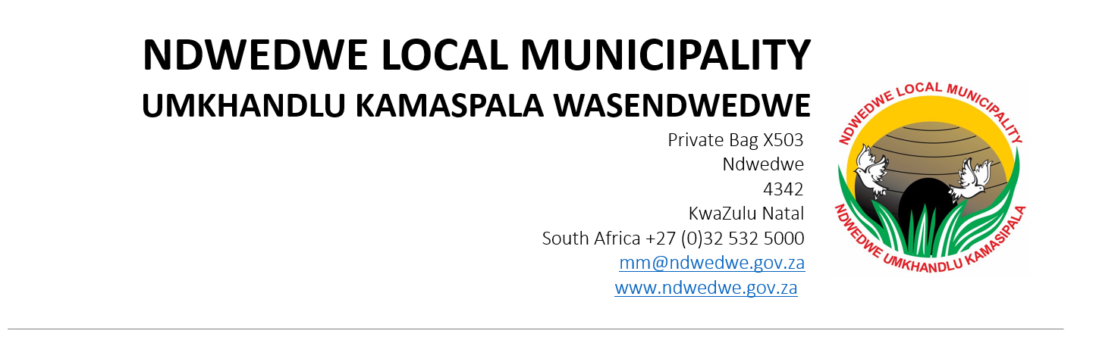
PUBLIC NOTICE

2025/2026 SERVICE DELIVERY AND BUDGET IMPLEMENTATION PLAN (SDBIP)

Ndwedwe Local Municipality hereby gives notice to the public in terms of Chapter 7, Section 53(3)(a) of the Municipal Finance Management Act, 2003 (Act 56 of 2003) that 2025/2026 Service Delivery and Budget Implementation Plan has been approved by His Worship the Mayor, Cllr S.Z. Mfeka at an Executive Committee meeting on 25 June 2025. The documents can also be accessed through the municipal website at: www.ndwedwe.gov.za.

Comments and suggestions can be forwarded to: The Municipal Manager’s Office, Private Bag X503, Ndwedwe, 4342 or hand-delivered within 21 days from the date of publication. Any person who cannot write may come during office hours for an official to transcribe or contact the Public Participation and/or PMS/IDP Office on 032 532 5000.

MR S.D.G KHUZWAYO
MUNICIPAL MANAGER

